**Technomania-2018**

**Software Category**

**The Confused**

First aspire

Then inspire

Before you expire.

Zero tolerance against all injustice.

Let the tiny dynamic device get used as the weapon against all offense, all immorality. The main objective of this mobile app is to use the mobile phone for counter terrorism and to reduce different criminal activities. This application will be under the supervision of the Security Force Department. There are many criminal activities which is happening around us and we, the general people are the victims. We have a very active and responsible Security Force Department and And they are watchful and vigilant performing their job. The mass people are also helping our security force department to do their job perfectly.Now it is going to be easier for the people to communicate with the security force department with the help of the Bachao app. User can download this app to communicate with the security force to complain any kind of criminal activity. Any kind of suspicion can also be complained.

**Project Summary:**

This mobile app is only for Android phone. The app is in JAVA language. The contents of the complains are stored in FIREBASE online database and SQLite offline database. The user need to be connected with internet to submit any complain. Else the complain will be stored in offline database. When the user will connect to the internet the contents of the complain will automatically be uploaded in the online database.

**Features:**

Different features are added which can make the app so much user friendly.

* **Report Crime:** User can report against any kind of criminal activity. There are different categories to choose to report crime like terrorism, extremism, cybercrime, bomb/explosives/arms related, narcotics/drugs related, traffic rules violation, Wanted list. The page for reporting the crime is catagorized in some sections. Terrorism, Thief, Suspicous, Harrasment, Accident, Lost Item and Most Wanted. User can easily choose any options from this page to report crime.

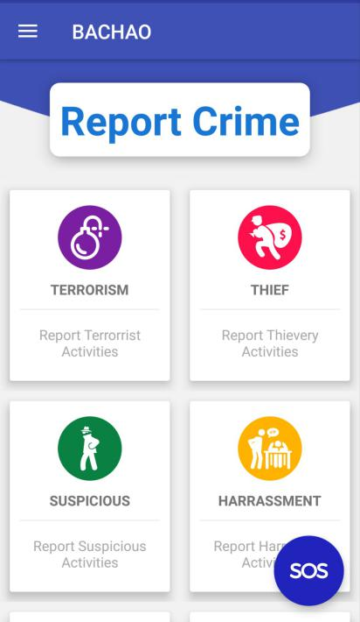

* **Graphical Report**: User can send or attach audio, image, and video on the basis of suspicion or proof.
* **Report Specification**: User can select area, police station to select where he want to complain or even provide address for better service.
* **Most Wanted List:** Security Force Department can attach information about most wanted criminal list. If user can get any information about them then they can inform police
* **User Manual:** There is a section where the user come to know about the application. If the user want to know detail about the app or he want to know how to use the application, he can learn this from this section.
* **User Profile:** The user have to fill up a form where he have to provide his information to register and login to his personal profile. This profile will remain secret from any others accept the user and the security force department.

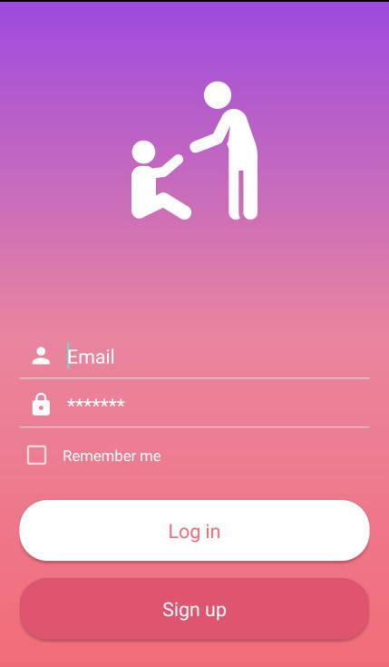

* **Emergency:** In case of any emergency like robbery, hijack and kidnapping, user can inform instant. The security force will take their necessary steps instantly.

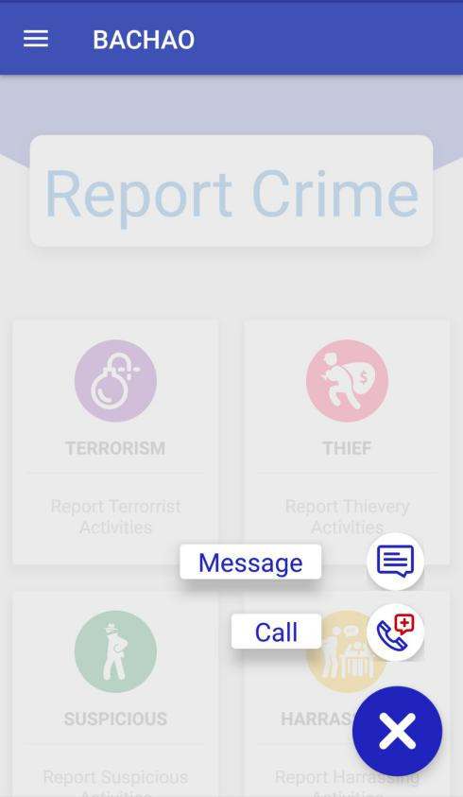

* **International Crime:** In this section user can report problem of international crime where criminals from Bangladesh are involved or Bangladesh will be victim of international terrorism.

**Tools:**

* An android phone device (Android Platform 4.4 (Kitkat) or higher)
* Active Internet Connection.

**Future Plan:**

* **Crisis Response:** A section for user for emergency rescue.
* **Blogging:** This is the section to post publicly for general people and also different department of government like: City Corporation, WASA, TITAS, PDB. The general can complain for any municipal problems. Different government announcements; posts like road blockage, repair; water, gas, electric power supply announcements will be posted here.
* **Emergency Location Tracking:** In case of emergency if the user need to contact secretly and rapidly with the Security Force Department, this mobile app will provide an emergency button. After clicking the button, the location of the user will be tracked and will send to the online database. Then the emergency rescue team will be sent from the Security Force Department.
* **Fire Brigade:** User can contact fire brigade at any instant.

**37. Contract Management Expert**

Tasks & Responsibilities

38. The tasks of contract management experts are as follows

• Review and approve the construction methodology and schedule submitted by

the contractor

• Implement a construction management system for the works

• Supervise and monitor the contractors activity to ensure satisfactory standards,

quality assurance, control of workmen ship and progress

• Approve the materials and equipment brought by the contractor

• Prepare and implement any minor adjustment required to the drawings and

plans with the consultation of PMU (Project Management Unit)

• Monitor the environmental impact during construction and coordinate with the

environmental management expert in the PMU

• Check monthly measurement of work and certify payment

• Coordinate with other specialists such as environment, community

development, resettlement, public awareness and training

• Implement other programs such as on site sanitation and drainage program as

reported by PMU

• Ensure that any dispute arising with day to day work is resolved at site level

• Advise PMU on claims, dispute and completion and defect correction

certification

• Report progress of work, which are likely outcome of contracts and other

related information required to the Team/ Deputy Team Leader.

• Assist PMU with handling legal matters with contractors regarding the

implementation of contract

• Participate in site meetings and will handle all variation orders

• Handle all claims from the contractors and will support the supervision

engineers (ARE and SARE) in all contractual matters

• Participate in commissioning and will keep track of outstanding works to be

carry out.

• check all safety measures both in works and labors

Qualifications and Experiences

39. The contract management experts should have a B.Sc. Engineering degree (Civil) and

preferably a Masteral or Post Graduation degree in Civil / Water supply Engineering. He/she

should have at least 12 years of experience including supervision of piped water supply

facilities of which at least 1 year should be in trenchless technology method and DMA

concept. Experiences with international organizations will be an added advantage.

Non-Key experts

60. Assistant Resident Engineer

Tasks & Responsibilities

61. The national Assistant Resident Engineer (ARE) will assist the DTL/CME to (i)

coordinate and supervise construction and installation of water supply Pipe line network

works in the field ii) monitor schedule and construction progress, and construction progress,

(iii) supervise quality of construction work, (iv) prepare monthly certificates, (v) review and

approve shop drawings and as-built-drawings, and(vi) prepare reports.

Qualifications and Experiences

62. ARE should have a Bachelor degree in civil engineering with a preferably of 3 years’

experience in Water Sanitary and Supply Networking construction, installation and is

proficient in both written and spoken English. Work experience in similar internationallyfunded

projects will be an advantage.

63. Sub Assistant Resident Engineer

Tasks & Responsibilities

64. Tasks of Sub Assistant Resident Engineer (Sub ARE) include: (i) reporting to the

ARE (ii) supervise and monitor the construction of works, prepare measurements for works

completed and in progress; (iii) certify contractors’ bills; (iv) Check the construction

schedule submitted by contractor, and assist contractor’s site manager to make detailed

construction plan; (v) report weekly and monthly construction progress and issues to the ARE

(vi) report field variations to the ARE or Construction Management Engineer and regularly

monitor physical and financial progress against the milestones, according to the contracts to

ensure the completion of the contracts on time; (vii) examine contractors’ claims for time

extension, variations, and additional compensation, etc., and recommend appropriate

decisions to the ARE or Construction Management Engineer; (ix) Assist PMU in resolving

contractual issues and overall contract management; and (x) ensure quality of construction as

per design specifications.

Qualifications and Experiences

65. Sub ARE should be a qualified engineer, with diploma in Civil Engineering and

preferably 5 years of experience in site supervision of construction works, out of which 2

years as a Quantity and cost Engineer. He/ she should have demonstrated ability to work in a

multidisciplinary team and excellent communication skills in spoken and written English.